**ICTPRG502_Assessment 2 - Practical Activity Answer Sheet Template**

Question 1 Determine, and document, the software development methodology to be used   
**>> SDLC (Waterfall Method)**

Question 2 Determine, and document, the project management software to be used  
**>> MS Excel**

Question 3 Determine the source-control system that will be used to manage the source code and to handle conflicts. Document the source-control system determined.   
**>> Git (see https://git-scm.com/book/en/v2/Getting-Started-About-Version-Control**)

Question 4 Determine, and document, the collaboration software to be used  
**>> Dropbox**

Question 5

NOTE:

The project activities are as follows:

|  |  |  |  |  |
| --- | --- | --- | --- | --- |
| **Task#** | **Task** | **Duration in Weeks** | **Start Date** | **End Date** |
| 01 | Planning | 3 | 28/01 | 17/02 |
| 02 | Design | 3 | 11/02 | 03/03 |
| 03 | Coding | 3 | 04/03 | 24/03 |
| 04 | Testing | 1 | 11/03 | 31/03 |
| 05 | Delivery | 1 | 01/04 | 07/04 |

Sample Work Breakdown Structure (WBS)

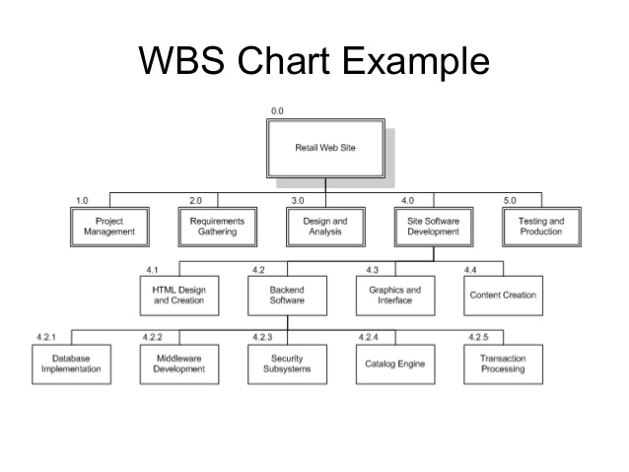

Sample Gantt chart

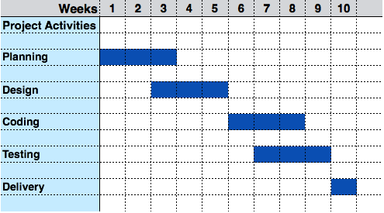

Sample PERT chart

|  |  |  |  |  |
| --- | --- | --- | --- | --- |
| **Task#** | **Activity** | **Duration in days** | **Start Date** | **End Date** |
| 001 | Design Website | 12 | 05/02 | 17/02 |
| 002 | Select Hosting Service | 3 | 16/02 | 19/02 |
| 003 | Implement Website | 25 | 17/02 | 14/03 |
| 004 | Test Website | 3 | 28/03 | 31/03 |
| 005 | Deploy to Production | 2 | 02/04 | 04/04 |
| 006 | Prepare Art Work | 15 | 17/02 | 04/03 |

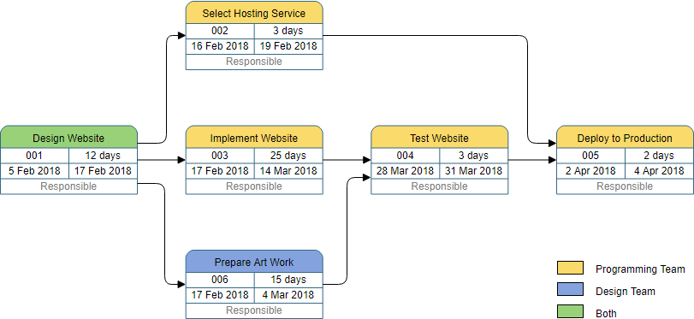

Question 6 and 9 See Appendix B Source Control Procedures (Git)

* List procedures on how to install Git in Linux (with screenshots of commands)
* List procedures on how to setup Git for the first time with screenshots of commands)
* List procedures on how to Get Help on Git with screenshots of commands)

**(see https://git-scm.com/book/en/v2/Getting-Started-About-Version-Control**)

Question 7 and 10 See Appendix C Collaboration Environment (Dropbox screenshots)

**Instructions:**

1. **Create a free Dropbox account**
2. **Create a Dropbox folder with “YourSID_SubjectCode”. For example, “S180353_ICTPRG502”**
3. **Upload the following documents to the Dropbox folder**
   1. **WBS**
   2. **Gantt chart**
   3. **Pert chart**
4. **Share the folder to at least 3 of your friends**
5. **Create screen shots of the Dropbox folder showing the documents uploaded successfully and shared with 3 friends**

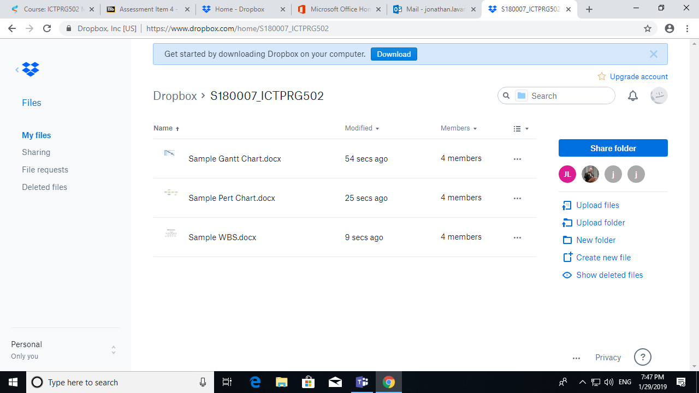

Question 8 See Appendix D Updated Project Plan (Gantt Chart, PERT chart)

The updated project activities are as follows:

|  |  |  |  |  |
| --- | --- | --- | --- | --- |
| **Task#** | **Task** | **Duration in Weeks** | **Start Date** | **End Date** |
| 01 | Planning | 3 | 28/01 | 17/02 |
| 02 | Design | 3 | 11/02 | 03/03 |
| 03 | Coding | 4 | 04/03 | 31/03 |
| 04 | Testing | 3 | 18/03 | 07/04 |
| 05 | Delivery | 1 | 08/04 | 14/04 |

Update the Gantt chart and Pert chart to reflect the changes above.